Stress-Testing SeSE: Robustness and Failure Analysis of LLM Uncertainty Estimation

Abstract
Large language models (LLMs) can generate fluent responses that remain factually incorrect, making uncertainty estimation central to reliable deployment. Existing semantic uncertainty methods improve on token-level measures by grouping responses according to meaning, but the structural behavior of semantic-graph uncertainty signals under controlled changes is less directly characterized [2,3,6]. We investigate this behavior using Semantic Structural Entropy (SeSE), preserving the original structural-entropy implementation while constructing an independent evaluation layer around it. The study evaluates six complementary dimensions: scaled case evaluation, clustering-threshold sensitivity, semantic-graph perturbation, repeated-score stability, complexity variation, and structural failure mechanisms. Across five tested clustering thresholds, structural entropy varied by only 0.000198. Under controlled perturbation, the maximum relative entropy change was 0.320876 for edge-weight noise and 0.144263 for edge dropout. Eleven repeated evaluations yielded a standard deviation of 0.849235 and an observed range of 2.260093. In seven scaled cases, all five factual cases produced a [5,1] cluster structure in which the single incorrect response formed a singleton, whereas the two reasoning cases produced [3,2,1] and [4,1,1] structures. These findings indicate a selective robustness profile rather than uniform stability: threshold variation was comparatively benign, while graph-weight perturbation and repeated evaluation produced larger score variation. The results provide a pilot-scale structural characterization of SeSE and identify concrete directions for larger, statistically controlled validation.
1. Introduction
LLMs can produce fluent but non-factual outputs, creating a reliability problem for downstream use and motivating uncertainty quantification as a means of assessing when generated content should be trusted or verified [3,4,5]. Hallucinated or unsupported responses can be difficult to identify from surface fluency alone, motivating uncertainty quantification (UQ) as a mechanism for reliability assessment and selective use. Recent UQ literature distinguishes multiple approaches, including probability-based, representation-based, sampling-based, and black-box behavioral methods [3,6,9]. Sampling-based methods such as SelfCheckGPT and self-consistency use agreement across generated outputs as an uncertainty-relevant signal [7,8]. Semantic uncertainty is particularly relevant because different textual realizations can express the same underlying answer; treating lexical variation as uncertainty can therefore exaggerate disagreement.
Semantic entropy established an influential response-level formulation by grouping generations according to semantic meaning before computing uncertainty [2]. Related work has also explored alternative semantic-similarity representations for uncertainty estimation, including contrastive semantic similarity [10]. Farquhar et al. showed that semantic grouping can outperform naive sequence-level entropy for detecting confabulation and demonstrated the value of semantic consistency across multiple generated answers [2]. SeSE extends this direction by representing semantic relationships structurally and using structural entropy over a hierarchical abstraction of the response space. The original SeSE study introduces structural information as an additional source of uncertainty information and reports empirical evaluation across 24 model-dataset combinations [1].
The question addressed here is narrower and complementary: how does the structural uncertainty signal behave when the graph construction is subjected to controlled changes? Aggregate discrimination metrics can show whether estimator separates correct from incorrect outputs, but they do not fully reveal whether the underlying score is sensitive to clustering choices, graph perturbations, repeated evaluation, response complexity, or particular error configurations. Such structural diagnostics matter because a score can perform well on aggregate while still exhibiting instability or systematic failure modes in specific settings.
We therefore ask: How robust, stable, and diagnostically informative is semantic-graph structural entropy as an uncertainty signal for LLM-generated responses? We address this question through six coordinated experiments. First, threshold sensitivity tests whether the final entropy changes materially across clustering thresholds. Second, perturbation experiments separately examine edge-weight noise and edge dropout. Third, repeated evaluations quantify score variability. Fourth, complexity experiments examine entropy variation across controlled semantic/reasoning conditions. Fifth, scaled evaluation expands the case-level analysis to seven questions. Sixth, failure-mechanism analysis examines how incorrect responses are positioned within semantic clusters.
The study makes four empirical contributions. First, it provides a multi-axis empirical characterization of the structural behavior of SeSE rather than evaluating only aggregate discrimination. Second, it quantifies sensitivity to intermediate graph-construction choices and explicit graph perturbations. Third, it connects score variability to repeated evaluation and response complexity. Fourth, it examines concrete structural configurations associated with incorrect responses, producing interpretable case-level evidence that complements aggregate metrics.
2. Related Work
LLM uncertainty estimation has developed rapidly because fluent generation does not guarantee factual reliability. Recent surveys organize UQ methods into multiple families and emphasize the need for evaluation protocols that connect uncertainty scores to reliability outcomes [3,6]. Hallucination research likewise distinguishes factuality, faithfulness, and detection settings rather than treating all non-factual generation as a single phenomenon [4,5]. Semantic entropy is a particularly relevant precedent: it estimates uncertainty over meanings rather than exact token sequences and uses semantic clustering to avoid counting paraphrases as independent answers [2].
The present study differs in emphasis rather than replacing these approaches. SeSE introduces structural information by constructing a semantic graph and an optimized hierarchical abstraction, with structural entropy serving as the uncertainty quantity [1]. This is conceptually adjacent to semantic-similarity approaches that use NLI or contrastive representations to characterize response dispersion [2,10]. The original work also establishes theoretical and empirical properties of SeSE, including its relationship to semantic entropy and its performance across 24 model-dataset combinations [1]. Consequently, broader dataset expansion, model comparison, sample-count ablations, and generic hallucination detection are not treated here as novel contributions.
2.1 Positioning against representative approaches
Approach | Primary signal | Access requirement | Relationship to this study
Semantic entropy [2] | Semantic agreement/disagreement across generations | Black-box response access | Direct conceptual predecessor; our analysis probes structural behavior beyond semantic grouping
SelfCheckGPT [7] | Cross-sample consistency and contradiction | Black-box response access | Motivates repeated-response analysis; does not construct a structural-entropy graph
Self-consistency [8] | Agreement among sampled reasoning paths | Black-box generation | Related sampling principle, but designed for answer selection rather than uncertainty-structure diagnosis
CSS [10] | Contrastive semantic similarity | Black-box response access | Alternative semantic representation; highlights sensitivity to how response relationships are encoded
LM-Polygraph [6] | Benchmarking multiple UQ families | Model/output access depending on method | Establishes the need for controlled, comparable UQ evaluation
SeSE [1] | Semantic graph + hierarchical structural entropy | Black-box response access | Foundational method evaluated here; this study interrogates its robustness and failure structure

Instead, this study targets a more specific empirical gap: the structural conditions under which a semantic-graph uncertainty signal remains stable, changes under controlled graph perturbations, or exhibits recognizable failure configurations. This distinction is important because an uncertainty estimator may have strong aggregate AUROC or AURAC while its score remains sensitive to intermediate representation choices or generation variability. Our experiments therefore complement, rather than reproduce, the principal performance claims of the original SeSE study.
3. Methodology
3.1 SeSE-preserving evaluation framework
The evaluation layer deliberately preserves the original SeSE implementation [1], including its structural-entropy computation rather than replacing the method with a generic entropy statistic. The independently developed experiment scripts import the original semantic-graph construction and structural-entropy routines from the reference implementation rather than substituting a generic Shannon entropy calculation. In particular, structural entropy is computed through the original compute_se routine. This design separates the object of study—the SeSE method—from the experimental controls used to interrogate its behavior.
3.2 Semantic-response graph construction
For a question q, the evaluation begins with a response set R = {r1, ..., rn}. Each response constitutes a graph node. Semantic processing groups responses into clusters, after which pairwise natural-language-inference relationships are used to assign weights to eligible response pairs, following the semantic-relationship construction used in SeSE and related semantic-UQ work [1,2,10]. The resulting weighted adjacency matrix represents the semantic organization of the sampled response set [1]. If the graph is disconnected, the original construction applies a connectivity correction so that the final graph can be evaluated structurally [1].
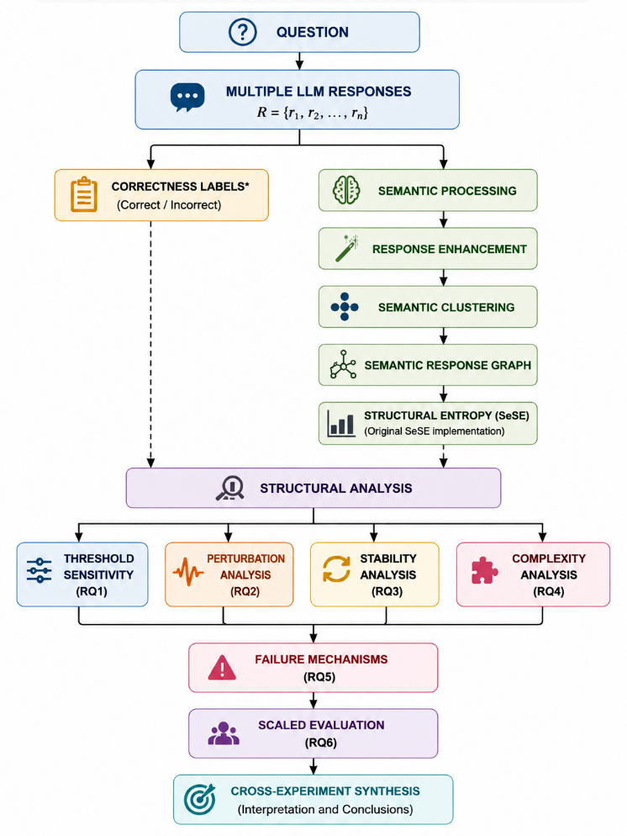
Figure 1: Overall experimental pipeline for evaluating SeSE-based LLM uncertainty estimation. Correctness labels are used only for retrospective analysis.
Figure 1 summarizes the overall experimental pipeline used in this study. The workflow begins with a question and a set of LLM responses, followed by semantic processing and construction of the SeSE response graph. Structural entropy is then computed using the original SeSE implementation. The resulting uncertainty signal is evaluated through complementary experiments targeting threshold sensitivity, semantic perturbation, repeated-score stability, semantic/reasoning complexity, and failure mechanisms, followed by scaled evaluation and cross-experiment synthesis. Correctness labels are maintained separately for retrospective error analysis and failure-mechanism diagnosis; they are not provided to the semantic graph construction or structural-entropy computation.
3.3 Evaluation variables
The experiments manipulate or observe five structural dimensions: clustering threshold, edge-weight perturbation, edge dropout, repeated evaluation, and response/task complexity. Case-level correctness is represented as binary response labels, enabling comparison between graph structure and error location. The scaled evaluation uses six deterministic responses per question, producing 42 responses across seven cases.
4. Experimental Design
The evaluation contains six complementary protocols.
Experiment | Purpose | Primary measurement | Cases/  observations
Scaled evaluation | Characterize case-level structure | Entropy, clusters, error location | 7 cases
Threshold sensitivity | Test clustering robustness | Entropy range | 5 thresholds
Perturbation | Test graph sensitivity | Relative entropy change | 24 observations
Score stability | Test repeated variability | SD and range | 11 repeats
Complexity | Examine complexity dependence | Entropy range | 5 conditions
Failure mechanisms | Examine incorrect-response structure | Cluster/error statistics | 3 cases
This design intentionally distinguishes robustness to an intermediate parameter from robustness to graph changes and from variability across repeated evaluation.
5. Results
5.0 Primary quantitative results
Dimension | Tested scope | Key result
Threshold sensitivity | 5 thresholds | Entropy range = 0.000198
Edge-weight noise | 12 observations within perturbation study | Max relative entropy change = 0.320876
Edge dropout | 12 observations within perturbation study | Max relative entropy change = 0.144263
Score stability | 11 repeats | SD = 0.849235; range = 2.260093
Complexity | 5 conditions | Entropy range = 0.422950
Scaled evaluation | 7 cases / 42 responses | Mean incorrect fraction = 0.166667; 5 confident-failure cases
Failure mechanisms | 3 cases | 2 confident-failure cases; mean cluster imbalance = 2.666667

5.1 Threshold robustness
Across the five tested clustering thresholds, structural entropy varied by only 0.000198.
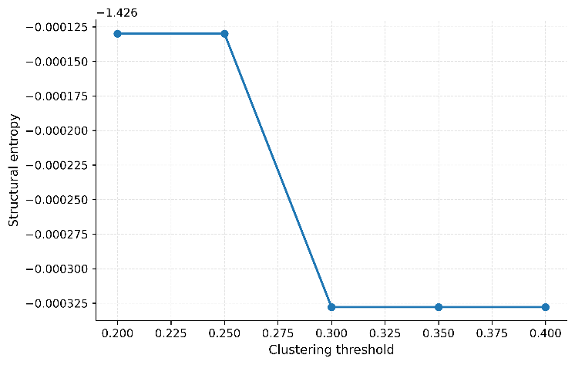
Figure 2: Structural-entropy sensitivity to clustering threshold.
Figure 2 shows the corresponding near-flat entropy trajectory. The key observation is that the final uncertainty quantity changed very little even though cluster assignments can change within the tested threshold range. Thus, for this evaluation regime, the structural entropy score was comparatively insensitive to the threshold used to organize semantic responses. This result should not be generalized beyond the tested thresholds or interpreted as evidence that clustering itself is invariant.
5.2 Response to semantic-graph perturbations
The perturbation experiment revealed a substantially different response profile. At the strongest tested perturbation condition, edge-weight noise produced a maximum relative entropy change of 0.320876, compared with 0.144263 under edge dropout. The corresponding relative graph-change measures at these maximum tested conditions were 0.244347 for noise and 0.000406 for dropout.
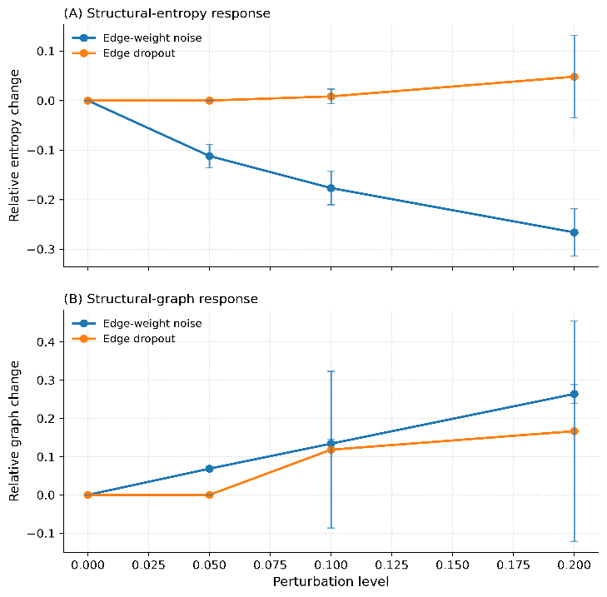
Figure 3: Semantic-graph perturbation response.
Figure 3 makes the asymmetry explicit: the entropy signal responded more strongly to perturbation of edge weights than to the tested dropout operation. The maximum relative entropy response under noise was approximately 2.23 times that under dropout. These values indicate measurable sensitivity to semantic edge-weight structure, while also showing that not all graph perturbations have comparable effects.
5.3 Repeated-score stability
The repeated-evaluation experiment produced 11 observations, with a structural-entropy standard deviation of 0.849235 and an observed range of 2.260093.
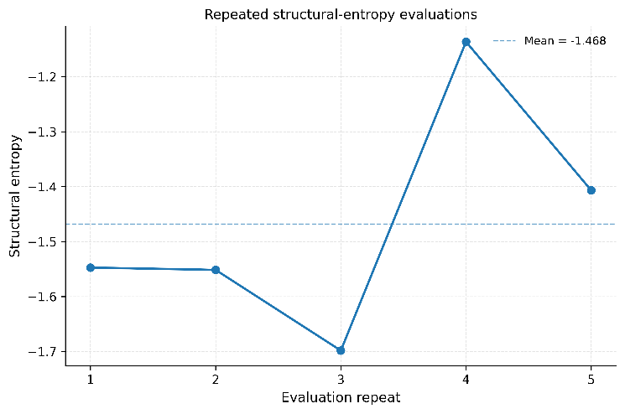
Figure 4:Repeated-score stability.
Figure 4 plots the individual scores rather than only an aggregate statistic, making the dispersion directly visible. This result qualifies the threshold-sensitivity finding: the score can be comparatively stable to the tested clustering threshold while exhibiting much larger variation across repeated evaluations. Because the two experiments manipulate different sources of variation and are not statistically matched, the magnitude difference should be interpreted as a descriptive contrast rather than a causal decomposition of variance.
5.4 Complexity and scaled case structure
Across five tested complexity conditions, structural entropy varied over a range of 0.422950. This establishes variation across the tested conditions but does not establish that complexity causes higher or lower uncertainty; the sample is too small for such an inference.
The seven-case scaled evaluation provides more interpretable case-level structural evidence. All five factual cases produced six responses partitioned into [5,1] clusters. In every factual case, the single incorrect response was the singleton cluster, yielding an incorrect-response fraction of 0.166667 and a confident-failure flag of True. The two reasoning cases instead produced [3,2,1] and [4,1,1] cluster structures, respectively. Each contained one incorrect response, but neither was classified as a confident failure.
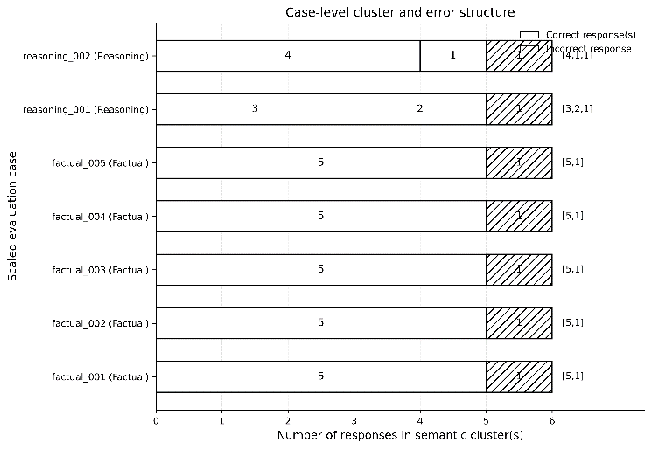
Figure 5: Case-level cluster and error structure across the scaled evaluation.
Figure 5 makes this contrast explicit. The five factual cases consistently exhibit a dominant five-response semantic cluster alongside a single-response singleton cluster, with the incorrect response occupying that singleton in every case. The reasoning cases are more fragmented, with responses distributed across three clusters rather than the two-cluster [5,1] structure observed for the factual cases. The pattern is consistent across the tested cases, but the seven-case evaluation remains too small to support broader claims about generalization across question types.
5.5 Cross-experiment synthesis
The combined evidence indicates a selective robustness profile rather than uniform stability. Threshold variation produced an entropy range of only 0.000198, whereas repeated evaluation produced an observed range of 2.260093 and semantic-graph perturbation produced relative entropy changes as high as 0.320876. At the case level, the five factual examples consistently isolated the incorrect response as a singleton semantic cluster, whereas the two reasoning examples exhibited more fragmented cluster configurations. Taken together, these results indicate that different sources of variation affect the structural signal differently: the score was highly stable across the tested threshold range but substantially more variable under repeated evaluation and graph perturbation.
6. Discussion
The threshold experiment suggests that, within the evaluated regime, the final structural-entropy quantity is less sensitive to clustering-threshold variation than the intermediate semantic partition. This is useful because clustering is a representational stage rather than the final uncertainty quantity. However, the perturbation experiment demonstrates that changing graph weights can materially alter the score. The contrast between noise and dropout is especially informative: weight perturbation produced a larger entropy response than the tested removal of edges, indicating that the magnitude of semantic relationships can matter even when the broad connectivity pattern remains recognizable.
The stability experiment provides the strongest qualification to a simple robustness narrative. Eleven repeated evaluations produced a score range of 2.260093, much larger than the 0.000198 range observed across the threshold experiment. Although these quantities arise from different experimental manipulations and should not be treated as directly comparable variance estimates, their contrast indicates that upstream evaluation variability deserves at least as much attention as clustering-threshold choice.
The case-level failure analysis provides a second form of evidence. In every factual example, the incorrect response formed a singleton against a five-response dominant cluster. This configuration is structurally intuitive: five responses occupy a shared semantic region while the erroneous response is separated from it. The reasoning cases were different, producing [3,2,1] and [4,1,1] partitions. These observations motivate a more systematic investigation of whether cluster imbalance, singleton formation, graph density, or edge-weight distributions can predict specific types of uncertainty failure.
The findings therefore support a restrained interpretation, consistent with the broader literature's emphasis on calibrated and benchmarked uncertainty rather than confidence claims alone [3,6,9]. Structural entropy captures meaningful changes in the semantic-response graph [1], and several graph configurations are visibly associated with response correctness in the evaluated cases. The present results establish an empirical robustness profile for the evaluated SeSE implementation and cases; they do not establish that structural entropy is a calibrated uncertainty estimator, a superior hallucination detector, or a universally stable uncertainty measure. At the same time, the current experiments do not establish calibrated probabilities of correctness, causal failure mechanisms, broad statistical significance, or superiority over competing uncertainty estimators. Those questions require larger datasets, independent response sampling, predefined statistical tests, and direct baseline comparisons.
7. Limitations and Conclusion
This study is intentionally a pilot-scale structural evaluation. The scaled evaluation contains seven cases and 42 responses; the other experiments also use small controlled samples. The scaled responses are deterministic and the current run encountered unavailable enhancement requests, triggering the original-response fallback. Accordingly, the scaled results characterize the fallback/original-response path rather than a fully enhancement-enabled evaluation. The experiments also do not provide cross-dataset generalization, calibrated uncertainty probabilities, causal identification, or a head-to-head predictive comparison against alternative uncertainty estimators.
Within these boundaries, the study establishes a concrete empirical profile of SeSE behavior. Structural entropy was highly stable across the five tested clustering thresholds, yet materially more variable under repeated evaluation and edge-weight perturbation. The scaled cases additionally show a recurring structural pattern in which incorrect factual responses occupied singleton clusters, while reasoning cases produced more fragmented response organizations. The resulting contribution is therefore not a claim of universal robustness, but a reproducible characterization of where structural entropy appears stable, where it is sensitive, and where its graph structure exposes potentially informative failure patterns. Larger multi-domain evaluation with repeated sampling, statistical confidence intervals, and baseline comparisons is the necessary next step for determining whether these pilot-scale structural signatures generalize.
References
[1] X. Zhao, H. Peng, D. Su, X. Zeng, C. Liu, J. Liao, and P. S. Yu, “SeSE: Black-box uncertainty quantification for large language models based on structural information theory,” in Proc. 42nd Conf. Uncertainty Artif. Intell., vol. 337, pp. 8209–8237, 2026.
[2] S. Farquhar, J. Kossen, L. Kuhn, and Y. Gal, “Detecting hallucinations in large language models using semantic entropy,” Nature, vol. 630, pp. 625–630, 2024, doi: 10.1038/s41586-024-07421-0.
[3] O. Shorinwa, Z. Mei, J. Lidard, A. Z. Ren, and A. Majumdar, “A survey on uncertainty quantification of large language models: Taxonomy, open research challenges, and future directions,” ACM Comput. Surv., vol. 58, no. 3, Art. no. 63, pp. 1–38, 2025, doi: 10.1145/3744238.
[4] L. Huang, W. Yu, W. Ma, W. Zhong, Z. Feng, H. Wang, Q. Chen, W. Peng, X. Feng, B. Qin, and T. Liu, “A survey on hallucination in large language models: Principles, taxonomy, challenges, and open questions,” ACM Trans. Inf. Syst., vol. 43, no. 2, Art. no. 42, pp. 1–55, 2025, doi: 10.1145/3703155.
[5] Z. Lin, S. Guan, W. Zhang, H. Zhang, Y. Li, and H. Zhang, “Towards trustworthy LLMs: A review on debiasing and dehallucinating in large language models,” Artif. Intell. Rev., vol. 57, Art. no. 243, 2024, doi: 10.1007/s10462-024-10896-y.
[6] R. Vashurin, E. Fadeeva, A. Vazhentsev, L. Rvanova, D. Vasilev, A. Tsvigun, S. Petrakov, R. Xing, A. Sadallah, K. Grishchenkov, A. Panchenko, T. Baldwin, P. Nakov, M. Panov, and A. Shelmanov, “Benchmarking uncertainty quantification methods for large language models with LM-Polygraph,” Trans. Assoc. Comput. Linguist., vol. 13, pp. 220–248, 2025, doi: 10.1162/tacl_a_00737.
[7] P. Manakul, A. Liusie, and M. J. F. Gales, “SelfCheckGPT: Zero-resource black-box hallucination detection for generative large language models,” in Proc. 2023 Conf. Empirical Methods Natural Language Process., pp. 9004–9017, 2023, doi: 10.18653/v1/2023.emnlp-main.557.
[8] X. Wang, J. Wei, D. Schuurmans, Q. V. Le, E. H. Chi, S. Narang, A. Chowdhery, and D. Zhou, “Self-consistency improves chain of thought reasoning in language models,” in Proc. Int. Conf. Learn. Representations (ICLR), 2023.
[9] G. Ahdritz, T. Qin, N. Vyas, B. Barak, and B. L. Edelman, “Distinguishing the knowable from the unknowable with language models,” in Proc. 41st Int. Conf. Mach. Learn., vol. 235, pp. 503–549, 2024.
[10] S. Ao, S. Rueger, and A. Siddharthan, “CSS: Contrastive semantic similarities for uncertainty quantification of LLMs,” in Proc. 40th Conf. Uncertainty Artif. Intell., vol. 244, pp. 77–87, 2024.

